**Bayes’ Theorem**

Using to solve classification problem base on the Bayes theorem

What is Bayes Theorem ?

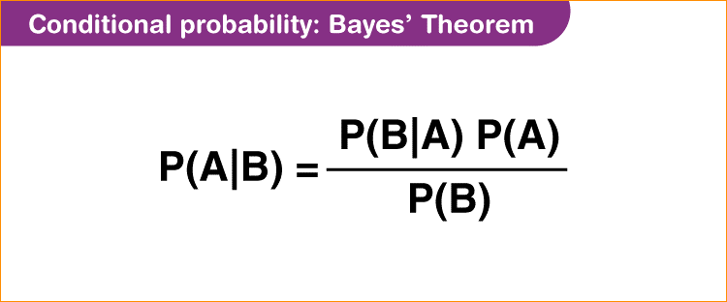

Let say you have two events –

There can be student who working very hard to face exam

There another student not working hard

After face exam two category = Pass exam or not pass exam

Another category work hard and not work hard

Now lets find the probability pass the exam when working hard.

R2

R3



R1

Not Work Well = B`

Pass the exam = A

Work Well = B

Let say there is class room and that has 100 students all those are observation(sample data)

This group devide into 2 groups –

1. Working hard
2. Working not hard

Finish the exam

1. Pass the exam
2. Fail the exam

Circle

So we have 4 made groups

I want to find the probability passing the exam when Student work very well.

Condition given – If Student work very well.

This is call conditional probability.

So using the baye’s theorem-

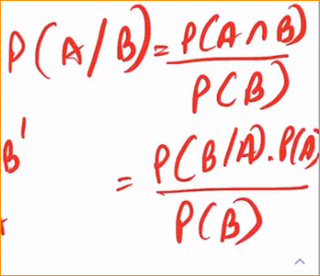

In this same Idea has in **Naïve Bayes Classifier**

**Naïve Bayes Classifier**

* Collection of classification algorithms based on Bayes Theorem
* Assume every pair of features being classified is independent of each other

Example data set

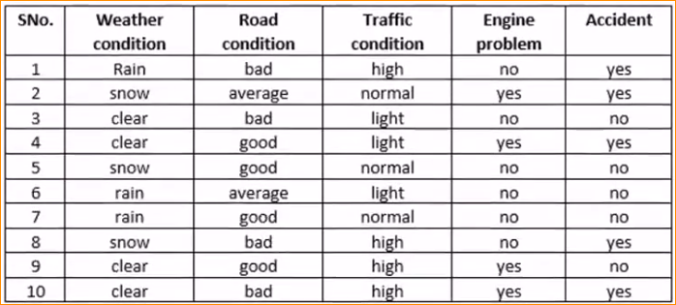

In here 4 input features

Prediction – Face the Accident or not

In here we are going to find the probability whether having a accident. Or not

Get 1st observation-

Given that - What is the probability of having a accident or not

P

(Accident = yes)

(Weather condition = Rain , Road Condition = bad , Traffic Condition = high, Engine problem = no)

Base on the higher probability we can predict face accident or not.

To do this we have get assumptions-

* These information independent of each other. (having weather condition rain nothing happen that road condition goes bad.)

Intersection of two event – each event should be independent.



Connect the Bayes theorem in to our data set -

Y – variable having accident or not

X – input Feature (in here 4)

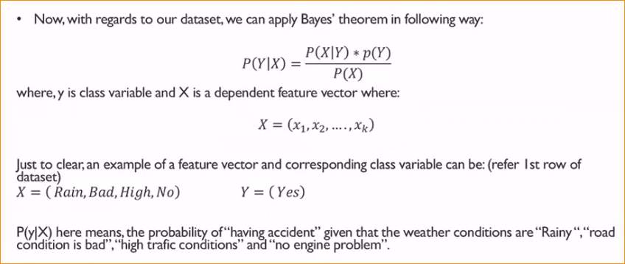

P(X|Y) 🡪 Intension of occurring an accident given some input features.

 🡪 What is the probability of having a input features

P(Y) 🡪 Probability having a accident or not

P(X) 🡪 Probability of having a input features

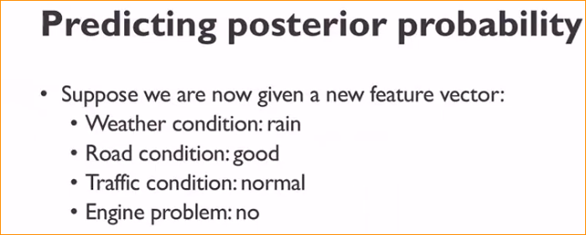

Now I want to find –

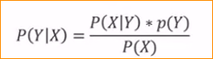

1 st we should find P(X|Y)

That mean -

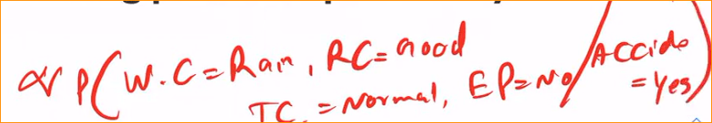

We can only taking the enumerator and refuse the denominator. Why ?

* To taking prediction, the denominator part not much important

So we can ignore the denominator since we're comparing P(positive | review) and P(negative | review) and so can cancel out their denominators to simplify our work.

**naive bayes theorem inversely proportional**

how to calculate –

in here data set has 10 observations.



P3

P2

P1

1. How many time there has been a accident – 5

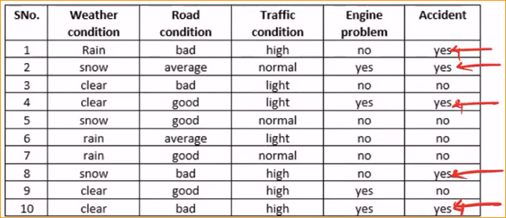

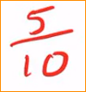

(Probability having accident )P3 – 5 / 10

1. Probability of



Assumption that all are independent –



Full equation –

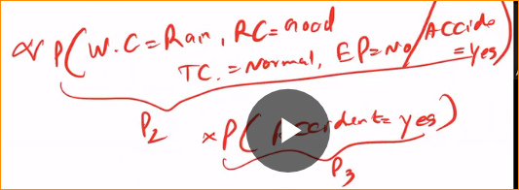

So multiplication one by one with assumption

In here we are divide like this – As a multiplication of 4 different probabilities

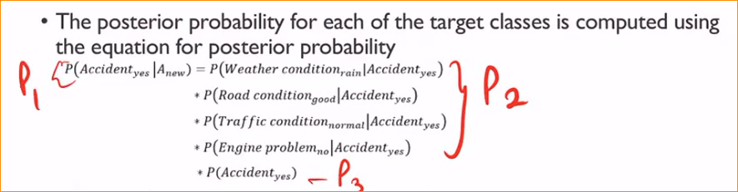

1. 

What is the probability of having a rainy weather condition that had an accident?

To find that I have divide data set in to two parts- having an accident and not having

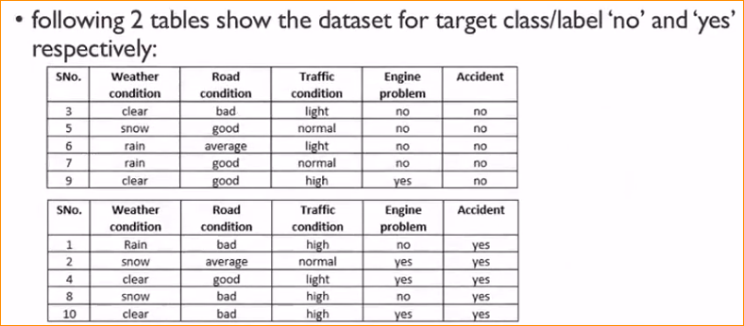

Orange box –

 = 1/5

Green box -

 = 1/5

Yellow box -

 = 1/5

Purples box -

 = 2/5

Red box –

 = 5/10

 (1/5)x(1/5)x(1/5)x(2/5)x(5/10)

= 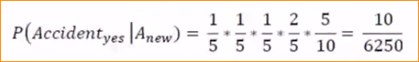

And probability of not having accident-

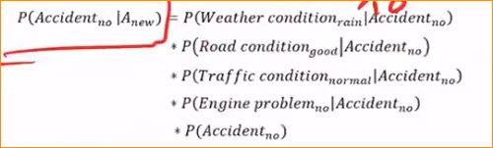

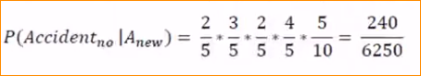

Finally, we are going to compare these two probabilities –



In here probability of not having accident is higher than probability of not having accident.